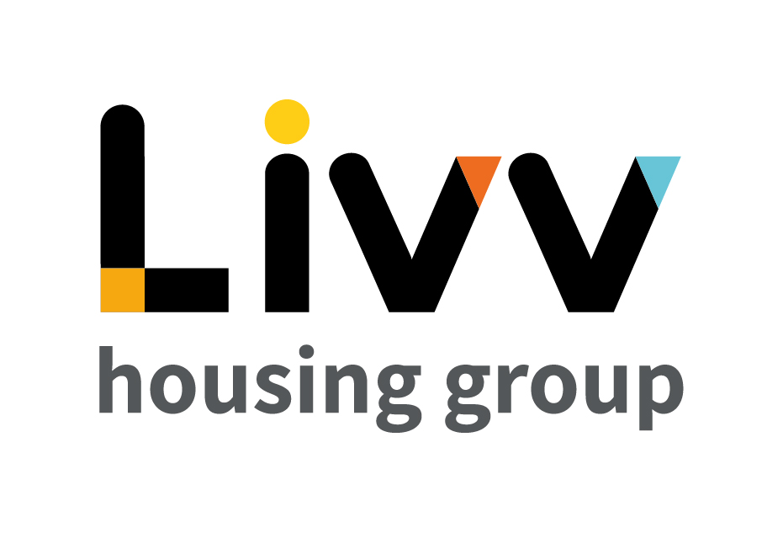

Job description

Job overview
Job title | Director – IT
Department | IT | Directorate | Resources
Reports to | Executive Director - Resources | Date | 2023
Directly responsible for | Head of IT  Manager – ICT Project Implementation  Manager – Cyber Security  Overall responsibility for the IT function | Job ref
Overall team / department purpose
- The IT function is responsible for ensuring that our network of systems functions properly and connects well.
- Maintaining the governance of the Group’s technological systems, maintenance of the infrastructure and functionality of the systems overall.
- Beyond that, professionals within the IT department work internally on computer software and hardware in many ways that allow a business to be successful.

Key role priorities
- This role is responsible for leading, managing, developing, and maximising the performance of the overall IT function for the Group.
- Ensuring the provision of effective and innovative strategies and consistently high-quality customer focused services which meet the needs and expectations of all customers and are aligned with the Group’s Vision, Values and Corporate Plan.
- Ensuring that regulatory and statutory requirements are met.
- The holder is required to demonstrate that the Group can demonstrate compliance and best practice to the Executive Team, Board, and shareholders across the remits of IT.
- As a member of the Director’s Team, the holder is expected to proactively contribute to operational planning, decision making and strategy implementation across the Group.

Key working relationships
- The role holder directly line manages the Head of IT, Manager - Cyber Security and Manager - ICT Project Implementation and is required to provide those role holders and the whole function with effective leadership, guidance, and support. This includes ensuring these functions continually have the capacity, skills, and commitment to support achievement of all Group wide objectives.
- The holder is required to influence, provide specialist advice to and work effectively with colleagues across the Group to ensure that their needs and objectives are understood and met and to ensure engagement with business improvement activity across the Group.
- External to the Group, the role holder is required to liaise effectively with external agencies, advisors and other stakeholders and organisations as appropriate and to represent the Group at high level in a broad range of settings.
- As a Director of the Group the holder is expected to provide peer leadership and challenge across functions to drive overall Group performance.
Main duties & responsibilities
- Provide leadership and shape strategies for the IT function, ensuring the Group continually has in place the most effective strategies and appropriately resourced associated plans and activities to meet its overall objectives.
- Oversee the adoption of digital technologies, to transform business operations using technology, systems, and processes and ensuring these are embedded and the benefits maximised.
- Driving our IT and digital strategy, and operational delivery plans.
- Analysing business requirements to determine and, where required, deliver the technology needs.
- Devising and establishing IT policies and systems to ensure our systems are safe, secure, effective
and support the implementation of our corporate plan.
- Mapping out the major priorities for digital and IT business systems transformation and improvement and acting as the champion and lead for innovation.
- Develop and oversee the IT transformation and improvement programme to ensure IT and digital needs are identified, costed, resourced, and provide a return on investment.
- Act as a role model for IT and broader related activity across the Group.
- Keep abreast of all latest trends and best practice via self, direct reports and broader team and ensuring the sharing of knowledge and ideas as appropriate with colleagues for Groupwide benefit.
- Manage the provision of regular reporting to Executive and Board level through the most effective use of relevant management information.
- Ensure a true business partnering approach to the provision of specialist support activities, including commissioned requirements internally and externally for the Group and clarity over requirements and delivery.
- Ensure risk, control and performance are embedded within the IT function and managed, monitored and reported in support of Group objectives.
- Ensure all target system service levels are maintained and that infrastructure improvements and projects are delivered in a timely manner.
- Ensure that the Group’s IT infrastructure and frameworks/policies are all fully compliant with all security, regulatory, legislative, and best practice.
- Identify and develop strategic external relationships that will enhance the provision of IT support activities, including the implementation of new products and services across the Group.
- Develop a high performing team, acting as coach, guide, leader, and supporter of all team members, via direct reports but also with broader functional influence.
- Act as a proactive member of the Director’s Team.
- Appoint, manage, and ensure the effective use of any external agencies or advisors.
- Effectively represent the Group - attending meetings, conferences, and events as appropriate.
- Complete any other tasks as commensurate with the level and nature of the posts as delegated by the role’s line manager.

Key measures of success
- Effective, innovative, clearly articulated and widely understood IT strategies and associated plans in place for the Group, clearly aligned to Group Vision, Mission, Values and Corporate Plans and supported by ongoing reporting and development.
- Achievement of strategic and operational objectives for the overall function.
- Recognition of excellence in service provision by internal customers.
- Most effective use of overall function resources and budget.
- Implementation of all Internal Audit recommendations.
- SLAs and KPIs met and where possible exceeded, particularly in respect of project outcomes and deliverables.
- Robust customer information, intelligence and profiles created and applied as appropriate.
- Policies delivered in line with customer demands and requirements.
- Effective leadership demonstrated through feedback and function performance.
- 3rd party supplier relationships managed to ensure the Group receives best value for money.
- Statutory and regulatory compliance requirements are achieved.
- Group capability and capacity improved as measured by performance management data and positive customer experience.

General
All employees are expected to:
- Ensure that our Customers are at the heart of everything we do and act at all times in accordance with our Values and Behaviours.
- Carry out all duties in the context of, and in compliance with, the Group’s commitment to equality and diversity, leading by example and contributing to an inclusive culture.
- Take responsibility for your own health and safety and that of your colleagues in accordance with the Health & Safety at Work Act by following the Group’s Health and Safety policies and procedures at all times.
- Adhere to all Group policies at all times.
- Understand and demonstrate empathy with the social aims of the Group.
- Ensure compliance with all legal obligations concerning the protection of data concerning
employees, customers and third parties.
- Be prepared to have some reasonable flexibility of working hours as necessary to meet the requirements of the job.
- Adopt a proactive approach to identify and mitigate risks to each business area by informing your line manager to enable the risk register to be updated, thus minimising the Group’s existing and future risks.
- Be prepared to work in a variety of locations as required, including premises not directly under the control of the Group.
- Demonstrate a willingness to undertake ongoing training as appropriate for ongoing personal and professional development and in line with the Group’s commitment to continuous improvement; demonstrate ongoing continuing professional development and take responsibility for identifying own development needs and actions to address these where appropriate.

Values and Behaviours
Making a difference daily | We invest in our people, our customers and in the creation of a fairer society.
Positively open | We are open to feedback at all time, as we strive to deliver a first class customer experience.
Forging the right way | We’re creating an inspiring road which others will want to follow
Together as one | Our teams work on another level of cohesiveness to enable us to deliver better outcomes.

Person specification
 | Essential | Desirable
Education and Qualifications
Degree or equivalent in IT or business-related subject or significant equivalent IT transformation experience. | X
Experience
Working at senior level in a similar/relevant function | X
Management of a team, ideally diverse in nature |  | X
Evidence of strategic leadership in IT transformation | X
Background in leading process improvement and automation projects | X
Employment in a customer service / public facing organisation |  | X
Employment in a housing / regulated environment |  | X
Excellence in the delivery of complex services |  | X
Managing IT projects with Group wide scope | X
Reporting to/working with or as part of Senior Management Teams and/or with Board or Committees | X
Comprehensive influencing skills at senior and strategic level |  | X
Skills, knowledge and ability
Ability to develop positive, effective, and engaging relationships with a broad range of internal and external stakeholders | X
Demonstrable business analysis and problem-solving skills | X
Full knowledge of business improvement and related methodologies and practices and ongoing commitment to awareness of relevant best practice | X
Ability to determine strategic direction for the function and Group and to effectively implement change management | X
Sophisticated people, project and budget management skills | X
Ability to meet targets and tight/multiple deadlines and to deliver continually improving performance in service delivery in a complex environment | X
Ability to work collaboratively with others to seek a joint resolution |  | X
Knowledge and understanding of working in a regulated environment |  | X
A strong understanding of the issues and challenges faced by the social housing sector |  | X
Fully literate in IT software packages to enable reports and data analysis at high level | X
High level of ability to gather, analyse and interpret information | X
Personal characteristics
A highly effective communicator, with proven ability to present information, challenge, influence and negotiate | X
A highly organised approach to function delivery and commitment to delivering an excellent customer focused service | X
Creative and commercially astute | X
Constructive and resilient approach to handling work related issues, with a solutions focus to problems | X
Proactive commitment to a continuous function and organisational improvement approach | X
Evidence of strong / inspirational leadership | X
Evidence of continual professional development | X
Other
Able to travel independently to a range of locations | X
Flexible approach to hours worked and willingness to attend evening or weekend meetings if required | X

