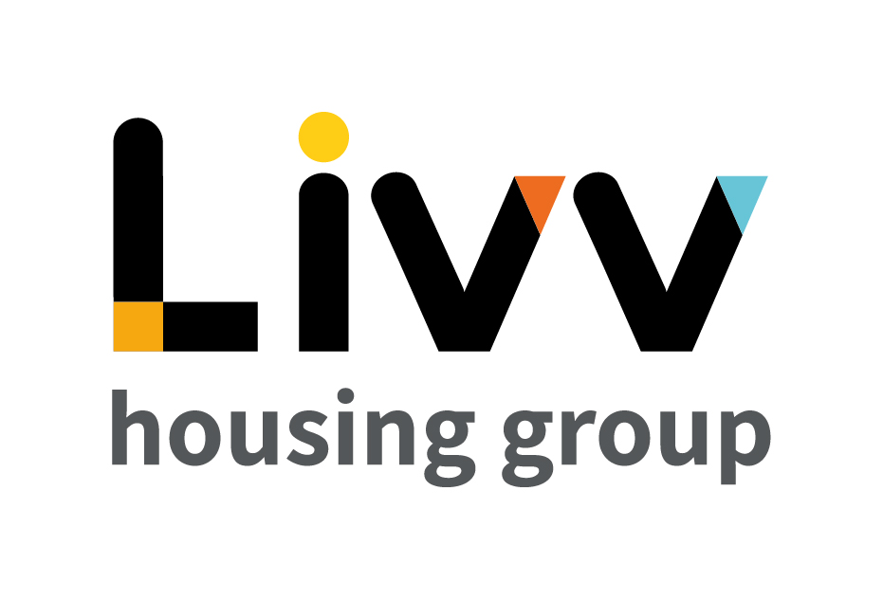

Job description

Job overview
Job title | Trainer – Learning & Development
Department | Human Resources (HR) | Directorate | Resources
Reports to | Manager – Learning & Development | Date | April 2022
Directly responsible for | No direct reports | Job ref | HR008
Overall team / department purpose
- The Human Resources (HR) Team is responsible for the effective provision of a value-adding strategic and operational people management programme for the Group.
- This includes all people related activities, with the overall aim of attracting, motivating, developing, and retaining high quality individuals with the skills and values that best support Group requirements and objectives.
Key role priorities
- This role is responsible for contributing to the provision of a proactive learning and development service which includes the design, delivery and embedding of learning initiatives in support of overall HR and business strategy.
- Specifically this involves being responsible for the design and delivery of learning interventions and materials for new starters and existing staff.
Key working relationships
- The role holder is required to work as a key member of the L&D team and alongside key stakeholders across the Group, working collaboratively with all teams across the Group to ensure that all relevant training needs are captured and understood and appropriate learning is developed, delivered, and embedded through appropriate learning interventions.
- External to the Group the role holder is required to interact with a range of external providers and stakeholders and prospective employees.
Main duties & responsibilities
- Identify, design, coordinate and deliver learning across the Group.
- Work with the L&D Team to evaluate all training activities, making improvements and enhancements as necessary to ensure that all learning is effective and keeping abreast of improvements and best practice.
- Work closely with the L&D team and internal customers across all functions to identify, design and deliver learning interventions for all systems used across the Group using a range of formats both face to face/classroom training workshops and online/self-study through use of the Group’s e-learning platform.
- Provide and support new employees through the induction process in all relevant systems for their role.
- Support line managers to solve specific learning problems and identify appropriate learning interventions.
- Ensure that key learning objectives and policies and procedures relevant to learning have been agreed for each course or workshop with the appropriate manager.
- Develop learning materials including user manuals, crib sheets and/or quick guides for all training sessions.
- Support and engage with the ongoing review of processes, policies and procedures to ensure that they are fit for purpose and provide value for money.
- Ensure best return on investment by delivering training interventions against the measures set by the Group.
- Support with the evaluation of training and development programmes and provide analysis to business areas.
- Complete any other tasks as commensurate with the level and nature of the post as delegated by the role’s line manager.

KEY MEASURES OF SUCCESS
- Individual, functional and organisational learning and development needs are planned for and delivered in the most effective manner, using the most appropriate methods/providers within the available budget.
- Learning activities are continually developed. delivered and embedded across the Group.
- All learning interventions ensure knowledge transfer is embedded.; training methods are continually updated to best reflect the Group’s changing requirements.
- Published training material is regularly reviewed and updated to remain in-line with current business practices.
- All Group employees are provided with the necessary training to make the most effective use of all systems / applications and equipment as appropriate to their role, using and with ongoing access to, appropriate training materials and resources.
- Data is maintained for relevant circulation to enable decisions to be made and reassurance provided based on training related statistics, enabling appropriate reporting, and informing ongoing service improvements.

General
All employees are expected to:
- Ensure that our Customers are at the heart of everything we do and act at all times in accordance with our Values and Behaviours.
- Carry out all duties in the context of, and in compliance with, the Group’s commitment to equality and diversity, leading by example and contributing to an inclusive culture.
- Take responsibility for your own health and safety and that of your colleagues in accordance with the Health & Safety at Work Act by following the Group’s Health and Safety policies and procedures at all times.
- Adhere to all Group policies at all times.
- Understand and demonstrate empathy with the social aims of the Group.
- Ensure compliance with all legal obligations concerning the protection of data concerning
employees, customers and third parties.
- Be prepared to have some reasonable flexibility of working hours as necessary to meet the requirements of the job.
- Adopt a proactive approach to identify and mitigate risks to each business area by informing your line manager to enable the risk register to be updated, thus minimising the Group’s existing and future risks.
- Be prepared to work in a variety of locations as required, including premises not directly under the control of the Group.
- Demonstrate a willingness to undertake ongoing training as appropriate for ongoing personal and professional development and in line with the Group’s commitment to continuous improvement; demonstrate ongoing continuing professional development and take responsibility for identifying own development needs and actions to address these where appropriate.

Values and Behaviours
Making a difference daily | We invest in our people, our customers and in the creation of a fairer society.
Positively open | We are open to feedback at all time, as we strive to deliver a first class customer experience.
Forging the right way | We’re creating an inspiring road which others will want to follow
Together as one | Our teams work on another level of cohesiveness to enable us to deliver better outcomes.

Person specification
 | Essential | Desirable
Education and Qualifications
HABC in Education and Training or similar training qualification and/or equivalent L&D experience evidenced | X
Experience
Designing and delivering training plans and resources  Developing and embedding end to end learning and development interventions  E-learning technologies, including being involved in the creation and/or delivery of e-learning packages | X  X | X
Skills, knowledge and ability
Ability to train in a variety of environments and to engage at all levels across the Group | X
Excellent verbal and written communication skills, including strong interpersonal and presentation skills | X
Use of a diverse range of learning and development interventions |  | X
Proficient in Microsoft Office | X
Ability to work effectively with a range of internal and external stakeholders | X
Ability to prioritise workload to meet deadlines | X
Personal characteristics
An enthusiast, flexible and highly customer focused approach, driven and committed to achieving successful outcomes | X
Able to work on own initiative with minimum supervision | X
A good team player and attention to detail | X
Other
A flexible approach to hours worked, including occasional out of hours work through attending meetings or delivering training | X

