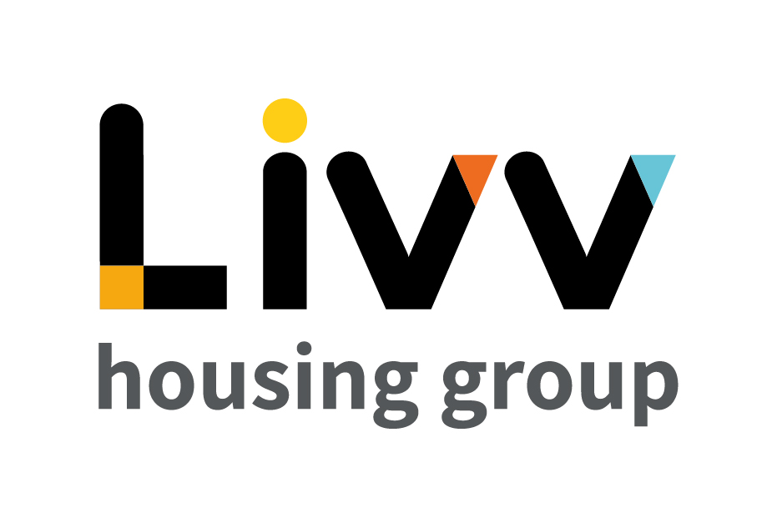

Job description

Job overview
Job title | Advisor – Community & Business Planning
Department | Community & Business Planning | Executive  Directorate | Customer Insight
Reports to | Manager – Operational Performance & Service Improvement | Date | January 2021
Responsible for | No direct reports | Job ref | CI009
Overall team / department purpose
With the overall aim of providing the Directorate with strategic direction, business intelligence, central coordination of continuous improvement activity to drive the directorate as a whole forward and business continuity, the Community & Business Planning function shapes the plans for Customer Insight and oversees effective delivery of these.
The team comprises of:
  - Operational Performance & Continuous Improvement, which uses data and predictive analytics to refresh policies and shape the continuous improvement programme to ensure that the operating model continues to meet customer need. Operational Performance & Service Improvement is a key enabling team spanning all Customer Insight functions and providing central knowledge, performance management, change and contract management, also owing the Business Continuity Plan, providing the leadership team with data reporting and analysis and delivering directorate wide service improvement initiatives.
  - Neighbourhood Planning & Community Investment – the team inputs into and shapes the Place Making and Regeneration agenda for Livv alongside teams from across the business. It develops detailed Community Investment plans that will be executed across the whole directorate, oversees the management of all external contracts relating to CI and plans, leads and embeds all customer engagement activity. Neighbourhood Planning & Community Investment shapes the direction and plans for the Directorate to ensure delivery of Corporate objectives taking into account external changes which impact these whilst managing key external stakeholder relationships at a strategic level.

Key role priorities
This role is responsible for the provision of support across the Community & Business Planning function. This includes completing analysis and administration to inform and support plans and actions across the function as required.

Key working relationships
This role is required to predominantly interact within the Community & Business Planning function but also more generally across the Directorate and broader Group as required.

Main duties & responsibilities
- Support the Manager, Operational Performance and Service Improvement in maintaining an up to date suite of policies and processes for the Directorate.
- Maintain the Knowledge Management solution for Customer Insight, ensuring processes are followed to maintain continually up to date and accurate data.
- Support the Manager, Neighbourhood Planning and Community Investment in developing plans to mitigate risks for the Group.
- Support the Customer & Community Engagement Officer through preparing information and plans and monitoring the delivery of these.
- Support the Neighbourhood and Community Investment Officers through the preparation of information to support Neighbourhood plans, bids, track progress and monitor outcomes.
- Providing ‘floating’ support to all Community & Business Planning function colleagues as required.
- Identify opportunities to improve the processes and feed these to the Manager, Operational Performance & Service Improvement.
- Complete any other tasks as commensurate with the level and nature of the post as delegated by the role’s line manager.
IREMENTS
Key measures of success
- Knowledge Management Solution is continually updated for Directorate use.
- Neighbourhood Plans are prepared, implemented and monitored being supported by appropriate data.
- All processes are complied with and developed over time as appropriate.

General
All employees are expected to:
- Ensure that our Customers are at the heart of everything we do and act at all times in accordance with our Values and Behaviours.
- Carry out all duties in the context of, and in compliance with, the Group’s commitment to equality and diversity, leading by example and contributing to an inclusive culture.
- Read, understand and demonstrate a commitment to the Group’s Employee Charter.
- Take responsibility for your own health and safety and that of your colleagues in accordance with the Health & Safety at Work Act by following the Group’s Health and Safety policies and procedures at all times.
- Ensure compliance with all legal obligations concerning the protection of data concerning employees, customers and third parties.
- Be prepared to have some reasonable flexibility of working hours as necessary to meet the requirements of the job.
- Adopt a proactive approach to identify and mitigate risks to each business area by informing your line manager to enable the risk register to be updated, thus minimising the Group’s existing and future risks.
- Be prepared to work in a variety of locations as required, including premises not directly under the control of the Group.
- Demonstrate a willingness to undertake ongoing training as appropriate for ongoing personal and professional development

Values and Behaviours
Making a difference daily | We invest in our people, our customers and in the creation of a fairer society.
Positively open | We are open to feedback at all time, as we strive to deliver a first class customer experience.
Forging the right way | We’re creating an inspiring road which others will want to follow
Together as one | Our teams work on another level of cohesiveness to enable us to deliver better outcomes.

Person specification
 | Essential | Desirable | Method of Assessment (see list below)
Education and Qualifications
3 GCSEs (Level 4 or above) or equivalent relevant customer service experience | X |  | AF, Certificates
Experience
Experience of working in/supporting a team | X |  | AF, I
Skills, knowledge and ability
Ability to work with data and to present subsequent findings | X |  | AF, I
Strong communication and interpersonal skills | X |  | AF,I
Knowledge of the social housing sector and/or understanding of the needs of the service  Experienced user of Microsoft Office packages | X | X | AF, I  AF, I
Personal characteristics
Customer focused  Confident and Resilient | X  X |  | I  I
Other
Flexible approach to hours worked | X |  | I

AF = Application form I = Interview T = Testing

