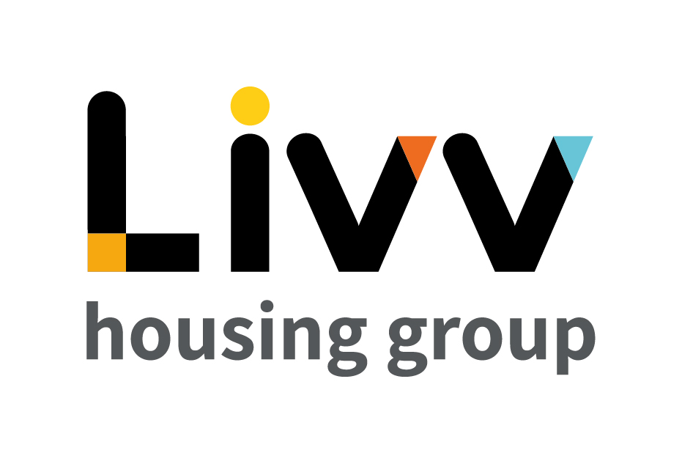

Job description

Job overview
Job title | Manager - Housing
Department | Customer Relationship Management | Directorate | Customer Insight
Reports to | Head of Customer Relationship Management | Date | January 2021
Responsible for | Advisors – Housing  Officer - Customer Liaison (Extra Care) | Job ref | CI012
Overall team / department purpose
With the overall aim of building strong customer relationships, sustaining tenancies, maximising income and ensuring the creation and management of safe and sustainable neighbourhoods, the Customer Relationship Management Team is responsible for all customer contact and issue resolution that either cannot be resolved at first point of contact or that comes from our proactive tenancy management role. The team comprises of:
  - Customer Relationship Management (CRM), which is responsible for being the primary contact for the customer throughout their tenancy, identifying where customers need additional support to maintain their tenancies and the management of safe communities. Resolution of complex queries that cannot be resolved at first point of contact sit alongside income collection that requires additional professional support and the responsibility for the resolution of complex queries and all complaints.
  - Advisory Services teams provide specialist support and guidance to customers for a defined period based on presenting need to enable them to sustain their tenancy and remain safe in their home and their community. These teams work closely with the Housing Advisors on a case management basis with the Housing Advisors maintaining the customer relationship at all times. Advisory Services also develops and maintain a network of partners to ensure that we can advocate for customers and works with partners on Safeguarding and ensuring safe and secure communities

Key role priorities
This role is responsible for overseeing the delivery of a Housing Advisor relationship based service to customers, ensuring resources are focused on providing support to those customers most in need, enabling them to live independently and sustain their tenancies.

Key working relationships
The role directly line manages a team of Housing Advisors and a Customer Liaison Officer (Extra Care) c. 10 FTE. The role holder is required to liaise with all colleagues across Customer Insight and more generally across the Group as appropriate. Externally the role holder is required to liaise with a range of external partner agencies.

Main duties & responsibilities
- Manage the Housing Advisors to ensure the delivery of an effective and efficient service which places the customer at the centre of all activities. Undertake Performance Management of the team, e.g., setting targets, reviewing performance against these, performing coaching and managing absence. Manage staff development e.g., identify training needs and source these via Learning and Development.
- Manage operational performance, e.g., allocate work, monitor the workload of the team against service standards, run performance meetings, day to day management of 3rd parties supporting service provision.
- Input to the Neighbourhood Plans and Community Investment projects, ensuring these are delivering to the needs of customers.
- Input to the development of policy and procedures refresh as required.
- Promote partnership working across teams in Customer Insight and across the Group to create a desire to deliver to a common set of objectives.
- Ensure process compliance across the team (e.g., that staff maintain accurate data on the systems and follow the agreed procedures for performing activities).
- Identify areas for improvement and feed these to the Head of Service.
- Provide accurate and timely information to the Head of Service to enable performance monitoring and value for money of the service and to demonstrate delivery of the Independent Living contract to KMBC.

IREMENTS
Key measures of success
- Effective team leadership and appropriate resourcing / work allocation based on particular area requirements.
- Process compliance (time, cost, quality)
- Lettings
- Customer Satisfaction
- Tenancies Sustained
- KMBC Contract delivery (Independent Living)

General
All employees are expected to:
- Ensure that our Customers are at the heart of everything we do and act at all times in accordance with our Values and Behaviours.
- Carry out all duties in the context of, and in compliance with, the Group’s commitment to equality and diversity, leading by example and contributing to an inclusive culture.
- Read, understand and demonstrate a commitment to the Group’s Employee Charter.
- Take responsibility for your own health and safety and that of your colleagues in accordance with the Health & Safety at Work Act by following the Group’s Health and Safety policies and procedures at all times.
- Ensure compliance with all legal obligations concerning the protection of data concerning employees, customers and third parties.
- Be prepared to have some reasonable flexibility of working hours as necessary to meet the requirements of the job.
- Adopt a proactive approach to identify and mitigate risks to each business area by informing your line manager to enable the risk register to be updated, thus minimising the Group’s existing and future risks.
- Be prepared to work in a variety of locations as required, including premises not directly under the control of the Group.
- Demonstrate a willingness to undertake ongoing training as appropriate for ongoing personal and professional development

Values and Behaviours
Making a difference daily | We invest in our people, our customers and in the creation of a fairer society.
Positively open | We are open to feedback at all time, as we strive to deliver a first class customer experience.
Forging the right way | We’re creating an inspiring road which others will want to follow
Together as one | Our teams work on another level of cohesiveness to enable us to deliver better outcomes.

Person specification
 | Essential | Desirable | Method of Assessment (see list below)
Education and Qualifications
Degree qualified in a relevant subject  Senior level experience in housing or a relevant service sector organisation | X | X | AF, Certificate  AF, I
Experience
Experience of leading teams in a challenging and target driven environment  Senior level experience of tenancy management | X  X |  | AF, I  AF, I
Skills, knowledge and ability
Knowledge and understanding of working in a regulated environment, including a strong understanding of the issues and challenges facing the social housing sector and of tenancy related legislation. | X |  | AF/I
An effective communicator with a proven ability to engage with, and build positive relationships with, a broad range of internal and external stakeholders. | X |  | AF/I
Evidence of strong leadership  Organised approach to service delivery | X  X |  | I  I
Personal characteristics
Customer Focused | X |  | I
Driven to achieve results  Good planning, organising and time management skills | X  X |  | I  I
Other
Flexible approach to hours and locations worked  Must be able to travel independently | X  X |  | AF, I  AF, I

AF = Application form I = Interview T = Testing

