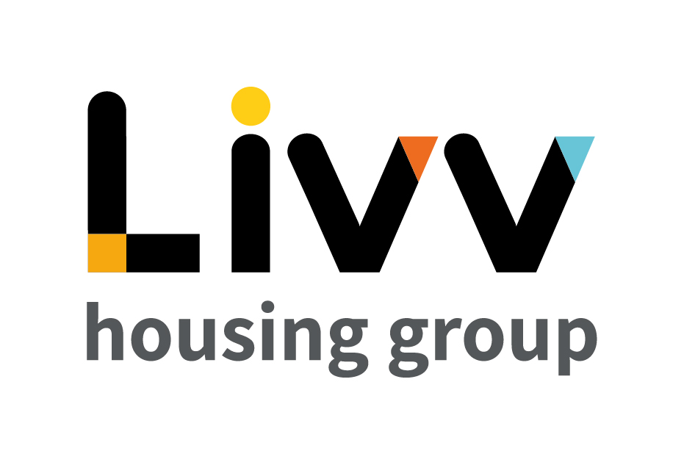
Job description

Job overview
Job title | Coordinator - Projects
Department | Business Improvement | Directorate | Resources
Reports to | Head of Business Improvement | Date | 2022
Directly responsible for | No direct reports
Overall team / department purpose
- The Business Improvement function uses a range of project and process improvement tools and techniques to enable business improvement projects and other activities to enhance performance improvement and process efficiencies for the Group.
- The aim of this function is to ensure that appropriate processes and procedures are continually in place to enable delivery of the overall strategically aligned change road map.

Key role priorities
- This role is responsible for overseeing the administration needs of the Group’s portfolio of projects and programmes.
- This involves supporting overall governance and management through coordinating the use of a common set of best practices, principles and templates for project management and supporting in the tracking of and reporting on projects and programmes across the Group. In addition, supporting and coordinating project activities.

Key working relationships
- The role predominantly supports the work of colleagues within the Business Improvement Team but will interact with colleagues across the Group as required, e.g., in attending project related meetings.
- There may be a requirement for the role to work with external providers, e.g. software providers, on a project by project basis.

Main duties & responsibilities
- Assist all members of the Business Improvement team by coordinating portfolio activities and initiatives to improve capability, this includes developing training material, communications and the analysis of information.
- Organise and schedule programme and project meetings with Boards, Steering Groups, Project Managers and other stakeholders. Support preparation of materials for meetings and ensure distribution in a timely manner.
- Assist the Head of Business Improvement in compiling Portfolio status reports.
- Maintain an accurate portfolio plan.
- Regularly update programme risks, assumptions, issues and dependencies (RAID) logs.
- Support the Head of Business Improvement in completing project reviews.
- Maintain team documentation and knowledge management across all project management systems and processes.
- Coordinate collection of feedback from the business in relation to PMO products / services e.g. project templates, governance processes.
- Support the Head of Business Improvement with resource management and benefit tracking, including maintaining a Portfolio benefits tracker.
- Attend project scoping, requirements and lessons learnt workshops as required and collate action points.
- Support with all Portfolio management administration tasks.
- Support and coordinate project activities.
- Take minutes at meetings and capture decisions, actions and RAIDs and update PMO systems accordingly.
- Maintain processes to ensure project management documentation, reports and plans are accurate and complete.
- Track and report on project portfolio performance, providing a real-time, comprehensive and prioritised view of all programmes and projects.
- Complete any other tasks as commensurate with the level and nature of the post as delegated by the role’s line manager.

Key measures of success
- Portfolio of programmes and projects are coordinated effectively and delivery optimised.
- Relationships with key stakeholders are developed and maintained to ensure the smooth delivery of the portfolio.
- Adherence to the project methodology and governance processes.
- Provision of accurate and timely data and information in relation to the portfolio.
- Provision of accurate and timely performance monitoring data and information.

General

All employees are expected to:

- Ensure that our Customers are at the heart of everything we do and act at all times in accordance with our Values and Behaviours.
- Carry out all duties in the context of, and in compliance with, the Group’s commitment to equality and diversity, leading by example and contributing to an inclusive culture.
- Take responsibility for your own health and safety and that of your colleagues in accordance with the Health & Safety at Work Act by following the Group’s Health and Safety policies and procedures at all times.
- Adhere to all Group policies at all times.
- Understand and demonstrate empathy with the social aims of the Group.
- Ensure compliance with all legal obligations concerning the protection of data concerning
employees, customers and third parties.
- Be prepared to have some reasonable flexibility of working hours as necessary to meet the requirements of the job.
- Adopt a proactive approach to identify and mitigate risks to each business area by informing your line manager to enable the risk register to be updated, thus minimising the Group’s existing and future risks.
- Be prepared to work in a variety of locations as required, including premises not directly under the control of the Group.
- Demonstrate a willingness to undertake ongoing training as appropriate for ongoing personal and professional development and in line with the Group’s commitment to continuous improvement; demonstrate ongoing continuing professional development and take responsibility for identifying own development needs and actions to address these where appropriate.

Values and Behaviours
Making a difference daily | We invest in our people, our customers and in the creation of a fairer society.
Positively open | We are open to feedback at all times, as we strive to deliver a first class customer experience.
Forging the right way | We’re creating an inspiring road which others will want to follow
Together as one | Our teams work on another level of cohesiveness to enable us to deliver better outcomes.

Person specification
 | Essential | Desirable
Education and Qualifications
A good standard of general education, 5 GCSEs at Grade 4 or above (or equivalent) including English and Maths or equivalent relevant experience | X
Project Management Qualification |  | X
Experience
Working in a project environment | X
Coordinating and updating programme / project plans | X
Budget coordination | X
Working to deadlines | X
Working as part of and providing support to a team | X
Skills, knowledge and ability
Excellent communication (written and oral) and interpersonal skills, including presenting, questioning & negotiation  Excellent attention to detail and ability to proof read  Able to engage & motivate others  Advanced use of IT packages including Excel & Visio | X  X  X  X
Personal characteristics
A highly organised and methodical approach to work | X
Customer focused and professional manner | X
Able to work on own initiative as well as supporting a team | X
Confident and resilient | X
Other
A flexible approach to hours worked  Able to travel independently | X  X

