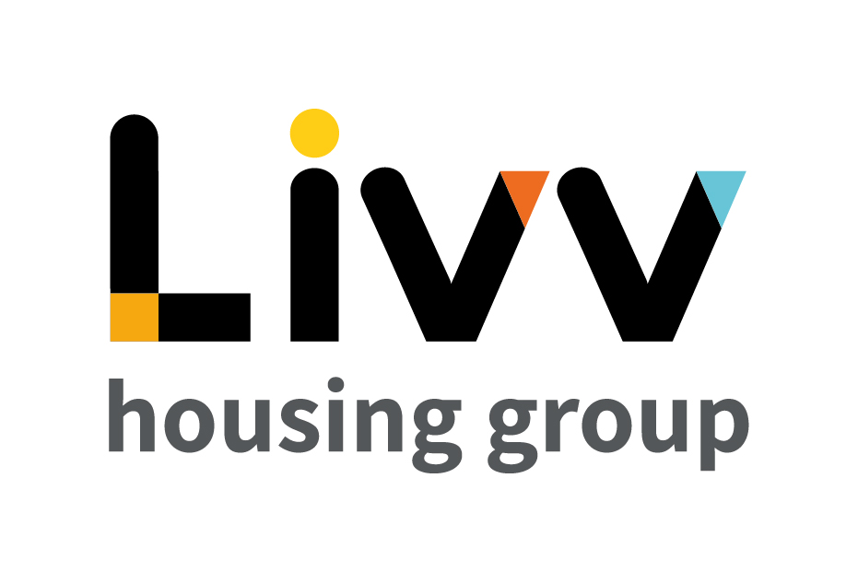
Job description

Job overview
Job title | Analyst – Data Intelligence
Department | Business Intelligence & Strategic Insight | Directorate | Finance, Risk & Performance
Reports to | Senior Analyst – Data Intelligence | Date | 2021
Directly responsible for | No direct reports | Job ref | (TBC)
Overall team / department purpose
The Business Intelligence & Strategy Insight Team is responsible for delivering the business intelligence strategies, providing high quality business intelligence solutions and robust insight that drive operational and executive decision making across the Group.

Key role priorities
- This role is responsible for building an effective and appropriate data warehouse environment which supports the business and insight capabilities for the Group.
- The holder is required to adhere to established data models and architecture to provide end-user Business Intelligence reports and self-service environments that provide the Group with timely access to accurate and relevant information and that supports the Strategic Insight capability.
Key working relationships
- The role holder is required to liaise with colleagues across the team, Directorate and Group more generally to ensure the provision of the most effective data warehouse environment to meet requirements.
- Externally the holder may be required to liaise with software providers to ensure the most appropriate systems to continually be in place to most efficiently and effectively meet changing Group data requirements.
Main duties & responsibilities
- Support the Senior Data Intelligence Analyst in improving the maturity of provision of Business Intelligence for the Group in line with the Business Intelligence Strategy.
- Adhere to data standards and definitions that meet the needs of the Group and comply with regulatory requirements.
- Ensure that all Business Intelligence processes and coding are relevant, adaptable and scalable to meet the needs of the Group.
- Build cross-functional intelligence from a centralised data repository using best practice data warehousing, ETL processes and self-service reporting environments.
- Maintain data integrity in the warehouse environment and support data quality and master-data management initiatives to align to the established architecture.
- Adhere to and support the Senior Data Intelligence Analyst in the design of any demand processes, change control, resource planning and roadmaps.
- Support colleagues and act as a credible expert in the structure and use of data, proactively influencing the Group to increase data awareness.
- Complete any other tasks as commensurate with the level and nature of the post as delegated by the role’s line manager.

Key measures of success
- Delivery of an accessible and accurate cross-functional warehouse.
- Delivery of a suite of quality, consistent and relevant reports in the Business Intelligence estate with low failure and query rate.
- Data protection and governance is adhered to with no material loss.

General
All employees are expected to:
- Ensure that our Customers are at the heart of everything we do and act at all times in accordance with our Values and Behaviours.
- Carry out all duties in the context of, and in compliance with, the Group’s commitment to equality and diversity, leading by example and contributing to an inclusive culture.
- Read, understand and demonstrate a commitment to the Group’s Employee Charter.
- Take responsibility for your own health and safety and that of your colleagues in accordance with the Health & Safety at Work Act by following the Group’s Health and Safety policies and procedures at all times.
- Adhere to all Group policies at all times.
- Understand and demonstrate empathy with the social aims of the Group.
- Ensure compliance with all legal obligations concerning the protection of data concerning
employees, customers and third parties.
- Be prepared to have some reasonable flexibility of working hours as necessary to meet the requirements of the job.
- Adopt a proactive approach to identify and mitigate risks to each business area by informing your line manager to enable the risk register to be updated, thus minimising the Group’s existing and future risks.
- Be prepared to work in a variety of locations as required, including premises not directly under the control of the Group.
- Demonstrate a willingness to undertake ongoing training as appropriate for ongoing personal and professional development and in line with the Group’s commitment to continuous improvement; demonstrate ongoing continuing professional development and take responsibility for identifying own development needs and actions to address these where appropriate.

Values and Behaviours
Making a difference daily | We invest in our people, our customers and in the creation of a fairer society.
Positively open | We are open to feedback at all time, as we strive to deliver a first class customer experience.
Forging the right way | We’re creating an inspiring road which others will want to follow
Together as one | Our teams work on another level of cohesiveness to enable us to deliver better outcomes.

Person specification
 | Essential | Desirable
Education and Qualifications
Degree level education - ideally in statistics, computer science, operational research or similar or equivalent relevant qualification / experience | X
MS SQL Certification |  | X
Experience
Demonstrable experience within an enterprise data warehouse and reporting estate | X
Skills, knowledge and ability
Demonstrable knowledge of SQL, T-SQL, SSIS, Stored Procedures, DAX and other associated processes | X
Practical knowledge of best practice data warehouse design principles | X
Knowledge of IT packages to support business area, including but not exclusively, Power BI, SSRS and Microsoft Office applications | X
Knowledge of statistics and ability to draw meaningful conclusions from large datasets |  | X
Able to communicate complex data to a wider audience | X
Effective communication and interpersonal skills and the ability to adapt personal styles appropriately | X
Ability to work in a collaborative manner, including joint working with other functions to achieve positive outcomes for customers | X
Personal characteristics
Self-motivated and resilient approach | X
Engaging style to embed organisational awareness | X
Other

