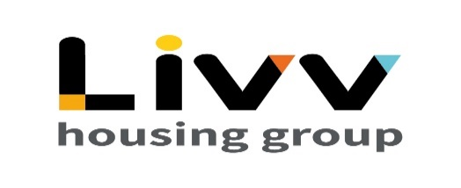
Gender Pay Gap Report
April 2021
Here at Livv Housing Group
58%
of our colleagues
are male

42%
of our colleagues
are female

Our mean
gender pay gap is
-7.6%

compared to the UK mean
in 2021
14.9%

Our median
gender pay gap is
0.0%

compared to the UK median in 2021
15.4%

Here we set out more detail of our gender pay gap and bonus pay gap along with the number of male and female colleagues in
each quartile of our pay ranges. Then we explain what we think the reasons are for the differences.

By law, we are required to publish data regarding our mean and
median gender pay gap information.
Our mean gender pay gap is7.1%% 7.1%7.1 7.1%%
-7.6%

The mean is our average pay. This is calculated by adding up all our salaries and dividing by the number of colleagues

Average Hourly Rate for a Female is
£17.60

Average Hourly Rate for a Male is
£16.40

Women’s mean hourly rate is 7.6% higher than men’s. In other words, when comparing mean hourly rates, women earn £1.08p for every £1 that men earn.

As can be seen from the Pay Quartile distribution (given below) there has been an increase in the number of females earning an hourly rate in the upper half of our pay bands.

0.0%
Our median gender pay gap is7. 1%% 7.1

The median is the middle value in our pay. This value is calculated by organising all of our salaries in order and picking the middle number.
%7.1 1%%

Median Hourly Rate for a Male is
£14.49

Median Hourly Rate for a Female is
£14.49

Women’s median hourly rate is 0.0% this is equal to men’s. In other words, when comparing median hourly rates, women earn £1 for every £1 that men earn.

By identifying the wage of the middle earner, the median is the best representation of the ‘typical’ difference as it is unaffected by the small number of very high earners.

Pay bands

Below is the summary split of where men and women sit in terms of the
quartile pay bands. We listed the salary of every colleague in order and split
the list into four equal parts to give us our quartiles A, B, C and D.

Band B – Lower Middle Quartile
49 Females 67 Males
42.2% Female
57.8% Male
Band A – Lower Quartile
52 Females 65 Males
44.4% Female
55.6% Male

Band D – Upper Quartile
54 Females 62 Males
46.6% Female
53.4% Male

Band C – Upper Middle Quartile
41 Females 75 Males
35.3% Female
64.7% Male

The percentage of females in the Lower Quartile has decreased while there has been an increase in the number of females in our Upper Middle.

Bonus
Here are the number of men and women eligible for bonus, as a percentage of the total headcount.

Number of Males
Receiving Bonus
96.3%

Men’s Bonus Pay is
-3.5%
0%
Lower - Mean and Median

Number of Females Receiving Bonus
96.4%

Women’s Bonus Pay is
3.5%
0%
Higher - Mean and Median

