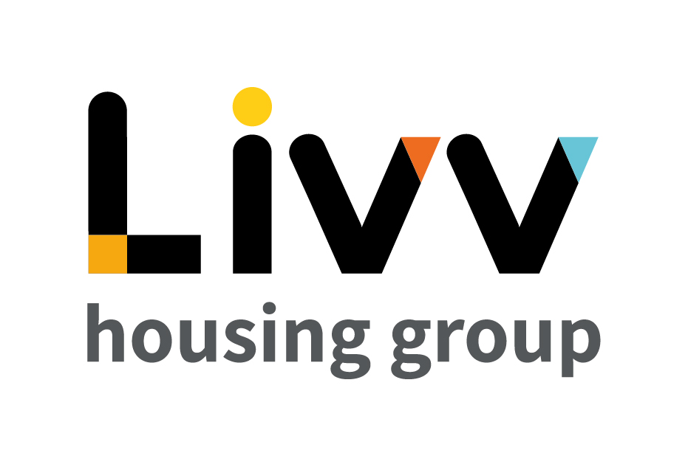

Job description

Job overview
Job title | Officer – Complex Income Collection
Department | Customer Relationship Management | Directorate | Customer Insight
Reports to | Manager – Complex Income Collection | Date | January 2021
Responsible for | No Direct Reports | Job ref | CI021
Overall team / department purpose
With the overall aim of building strong customer relationships, sustaining tenancies, maximising income and ensuring the creation and management of safe and sustainable neighbourhoods, the Customer Relationship Management Team is responsible for all customer contact and issue resolution that either cannot be resolved at first point of contact or that comes from our proactive tenancy management role.
The team comprises of:
  - Customer Relationship Management (CRM), which is responsible for being the primary contact for the customer throughout their tenancy, identifying where customers need additional support to maintain their tenancies and the management of safe communities. Resolution of complex queries that cannot be resolved at first point of contact sit alongside income collection that requires additional professional support and the responsibility for the resolution of complex queries and all complaints.
  - Advisory Services teams provide specialist support and guidance to customers for a defined period based on presenting need to enable them to sustain their tenancy and remain safe in their home and their community. These teams work closely with the Housing Advisors on a case management basis with the Housing Advisors maintaining the customer relationship at all times. Advisory Services also develops and maintain a network of partners to ensure that we can advocate for customers and works with partners on Safeguarding and ensuring safe and secure communities.

Key role priorities
This role is responsible for delivering a service to maximise the arrears income recovered for the Group for all types of arrears collection, proactively managing arrears cases to maximise tenancy sustainability and reduce turnover where appropriate.

Key working relationships
The role holder is required to work in partnership with colleagues across Customer Insight and more generally across the Group, for example in Finance, to deliver the required levels of customer service. Externally the role holder is required to deal directly with customers by telephone, email and pre-arranged face to face meetings where appropriate in respect of case management from an income perspective and 3rd parties, e.g. courts where required.

Main duties & responsibilities
- Case manage all arrears cases in accordance with the agreed policies and processes to maximise income collection for all types of arrears (rent, service charges, garages and rechargeable repairs).
- Proactively manage arrears cases to maximise tenancy sustainability and reduce turnover – i.e. place the customer at the centre of the case and identify actions that are relevant to their needs.
- Manage the eviction process in line with the legal framework.
- Develop good working relationships with the courts to support delivery of the required outcomes.
- Work in partnership with other teams to deliver the required level of customer service, e.g. refer customers to advisory teams where specialist support is needed.
- Ensure systems are updated with accurate and up to date information so that other teams are aware of the status of customer requests.
- Complete any other tasks as commensurate with the level and nature of the post as delegated by the role’s line manager.
IREMENTS
Key measures of success
- Process compliance (time, cost, quality)
- Income collection increased
- Arrears reduced
- Tenancies Sustained

General
All employees are expected to:
- Ensure that our Customers are at the heart of everything we do and act at all times in accordance with our Values and Behaviours.
- Carry out all duties in the context of, and in compliance with, the Group’s commitment to equality and diversity, leading by example and contributing to an inclusive culture.
- Read, understand and demonstrate a commitment to the Group’s Employee Charter.
- Take responsibility for your own health and safety and that of your colleagues in accordance with the Health & Safety at Work Act by following the Group’s Health and Safety policies and procedures at all times.
- Ensure compliance with all legal obligations concerning the protection of data concerning employees, customers and third parties.
- Be prepared to have some reasonable flexibility of working hours as necessary to meet the requirements of the job.
- Adopt a proactive approach to identify and mitigate risks to each business area by informing your line manager to enable the risk register to be updated, thus minimising the Group’s existing and future risks.
- Be prepared to work in a variety of locations as required, including premises not directly under the control of the Group.
- Demonstrate a willingness to undertake ongoing training as appropriate for ongoing personal and professional development.

Values and Behaviours
Making a difference daily | We invest in our people, our customers and in the creation of a fairer society.
Positively open | We are open to feedback at all time, as we strive to deliver a first class customer experience.
Forging the right way | We’re creating an inspiring road which others will want to follow
Together as one | Our teams work on another level of cohesiveness to enable us to deliver better outcomes.

Person specification
 | Essential | Desirable | Method of Assessment (see list below)
Education and Qualifications
3 GCSEs (Level 4 or above) or equivalent relevant customer service experience  Housing relevant qualification | X | X | AF, Certificates  AF, I
Experience
Previous experience of finance/pursuing debt in a busy, pressured environment |  | X | AF/I
Dealing with customers in a face to face/telephony environment | X |  | AF/I
Previous experience of working in a housing / service providing organisation, ideally in a finance related role | X |  | AF/I
Skills, knowledge and ability
Housing /income management policies and procedures |  | X | AF/I
Strong communication, interpersonal, teamwork and organisational skills | X |  | I
IT skills, including use of Microsoft Office packages | X |  | AF/I
Personal characteristics
Able to work under pressure, deal with conflict/difficult situations and meet deadlines | X |  | I
Confident and resilient – able to demonstrate empathy but with a firm and professional tone | X |  | I
Other
Flexible approach to hours and locations worked – role involves visits to customers homes | X |  | I
Must be able to travel independently | X |  | AF/I

AF = Application form I = Interview T = Testing

