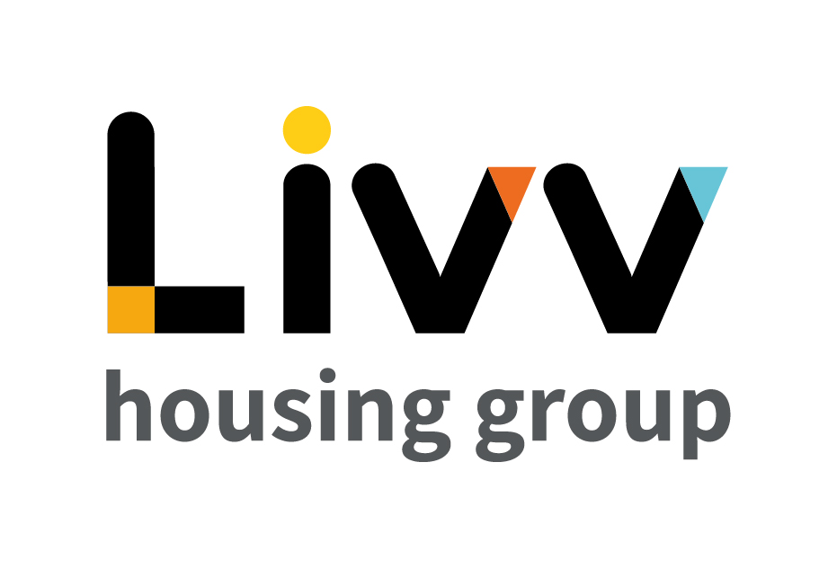

Job description

Job overview
Job title | Developer – Application Support
Department | IT / Business Improvement | Directorate | Resources
Reports to | Senior Analyst – Application Support | Date | 2022
Directly responsible for | No direct reports | Job ref | TBC
Overall team / department purpose
- The Business Improvement function overall uses a range of project and process improvement tools and techniques to enable business improvement projects and other activities to enhance performance improvement and process efficiencies for the Group, ensuring appropriate processes and procedures are continually in place to ensure delivery of the overall strategically aligned change road map.
- The IT function is responsible for ensuring the Group’s continuing ability to safely and effectively access and use information both internally and externally. This includes the provision of an effective IT Service Desk function, business continuity and back up plans and ensuring the most effective delivery of IT change projects.
Key role priorities
- This role is responsible for the provision of software application support to users for various different software applications, resolving issues directly or working with third party software vendors to ensure that system fixes and/or enhancements are effectively implemented within agreed timescales and in line with service level agreements.
- The role also involves specialising in the specification, development and implementation of automated solutions, programmes and integrations, using appropriate technologies that continually improve business processes.
Key working relationships
- As well as the IT team, the holder is required to interact on a regular basis with all users, these comprising colleagues across all levels and functions of the Group.
- The holder is also required to liaise in particular with relevant Business Partners in respect of the software systems for which they are responsible.
- The holder is required to interact with external suppliers where needed to ensure resolution of incidents and take appropriate action, this in particular including providing an interface between the Group’s users and vendors’ IT Service Desk (helpdesk) functions.
Main duties & responsibilities
- Provide end users with day-to-day support and training in the use of the Group’s corporate business applications such as the housing management solution, finance systems, workflow systems, document management systems, HR and time recording systems and any interfaces into other systems.
- Administer the systems and their interfaces to the most recent released version of the software and wherever possible take responsibility for the upgrade and testing process as appropriate, liaising with Senior Application Support Analysts, software suppliers and network / server support staff.
- Liaise with vendors’ help desks to resolve application and interface problems, issues and bugs raised by end-users within agreed timescales.
- Act as Systems Administrator for the Group’s application software packages as assigned.
- Participate in the IT Service Desk (helpdesk) operation as part of a rotation of duties applying to most members of the IT Team.
- Work with users and vendors to ensure all interfaces to systems are correctly specified and working effectively to meet Group requirements.
- Ensure the integrity of assigned systems by password control and appropriate assignment of permissions.
- Evaluate business requirements, prepare and present proposal designs for IT solutions to meet agreed objectives within time scale and budget.
- Undertake business analyst process reviews to identify areas for improvement and recommend potential solutions.
- Develop and implement automated solutions, programs and integrations using appropriate technologies to meet business requirements, using appropriate technologies (SSRS, VB Scripts, Visual Studio, HTML, JavaScript, Python, C++, Powershell)
- Undertake and manage all testing of new developments before promotion to a production environment.
- Produce all training and systems documentation for new developments, ensuring both IT staff and end users are kept up to date with any system changes.
- Actively research emerging technologies and to assess their potential business benefit to the Group.
- Facilitate the operation of non–automated interfaces and receipt of housing benefit, cash or other postings into the Group’s systems.
- Be responsible for the support of mail merge functions.
- Document the configuration and operational procedures associated with applications.
- Undertake and assist in the acceptance testing of new upgrades / software patches prior to release to end users.
- Help identify/implement configuration amendments required as a result of changes in legislation or regulatory requirements.
- Maintain an effective two-way flow of jargon–free communication with system users and keep them appropriately and regularly updated on major system events that will affect their service or use of the system.
- Complete any other tasks as commensurate with the level and nature of the post as delegated by the role’s line manager.

Key measures of success
- All support requests/issues for programmes/applications assigned are addressed in line with service level agreements.
- Automation of key processes to reduce duplication or manual processing.
- Continuous improvement of existing process using latest technologies to enhance services.
- All documentation for assigned software applications and associated procedures are continually kept up to date.
- Adhere to Group IT Security Policy
- End users are made aware of any major changes / updates to applications and these are continually implemented as appropriate.
- Ongoing provision of range of software applications best positioned to meet Group needs.
- Effective IT Service Desk (helpdesk) provision available for end users at all times.

General
All employees are expected to:
- Ensure that our Customers are at the heart of everything we do and act at all times in accordance with our Values and Behaviours.
- Carry out all duties in the context of, and in compliance with, the Group’s commitment to equality and diversity, leading by example and contributing to an inclusive culture.
- Read, understand and demonstrate a commitment to the Group’s Employee Charter.
- Take responsibility for your own health and safety and that of your colleagues in accordance with the Health & Safety at Work Act by following the Group’s Health and Safety policies and procedures at all times.
- Adhere to all Group policies at all times.
- Understand and demonstrate empathy with the social aims of the Group.
- Ensure compliance with all legal obligations concerning the protection of data concerning
employees, customers and third parties.
- Be prepared to have some reasonable flexibility of working hours as necessary to meet the requirements of the job.
- Adopt a proactive approach to identify and mitigate risks to each business area by informing your line manager to enable the risk register to be updated, thus minimising the Group’s existing and future risks.
- Be prepared to work in a variety of locations as required, including premises not directly under the control of the Group.
- Demonstrate a willingness to undertake ongoing training as appropriate for ongoing personal and professional development and in line with the Group’s commitment to continuous improvement; demonstrate ongoing continuing professional development and take responsibility for identifying own development needs and actions to address these where appropriate.

Values and Behaviours
Making a difference daily | We invest in our people, our customers and in the creation of a fairer society.
Positively open | We are open to feedback at all time, as we strive to deliver a first class customer experience.
Forging the right way | We’re creating an inspiring road which others will want to follow
Together as one | Our teams work on another level of cohesiveness to enable us to deliver better outcomes.

Person specification

 | Essential | Desirable
Education and Qualifications
Degree or equivalent relevant experience in computer science or a business-related subject with a significant component of IT | X
Experience
Good knowledge of a range of software application package systems used by multiple users across an organisation, including e.g. financial systems, electronic invoice systems, HR systems, workflow systems, document management systems, management information reporting systems  Experience in Orchard Housing System | X | X
Working with system users to specify and then implement their requirements via software package vendors or software development | X
Systems administration and support of multiple user package application systems | X
Experience as a systems developer |  | X
Experience of working directly in collaboration with software vendor staff | X
Skills, knowledge and ability
Good knowledge and understanding of a selection of the following:  Systems Analysis  Flowcharting and process mapping  Workflow software  System Specification  Writing SQL / T-SQL  Relational databases such as SQL  SQL Server packages Incl. SSIS, SSRS  System Programming  Web design  Project Management Methodologies such as Prince 2 | X | X  X
Good communication skills (verbal and written), including the ability to explain and communicate IT issues effectively to non-technical audiences and to structure the thoughts of users into user specifications and reports. | X
A high level of analytical and problem-solving skills | X
Strong data analysis, reporting and statistical skills |  | X
Good interpersonal skills, including the ability to develop constructive working relationships with team members, system users and other colleagues across the Group and external contacts | X
Good attention to detail | X
Personal characteristics
An organised approach to work, including prioritising and working well under pressure | X
Results and customer focused, including a commitment to delivering an excellent and continually improving IT service for all system users | X
Calm and professional approach, including when handling difficult or contentious IT issues | X
Driven and resilient | X
Other
A flexible approach to hours worked as role may involve some out of hours requirements | X
Able to travel independently to other venues | X

