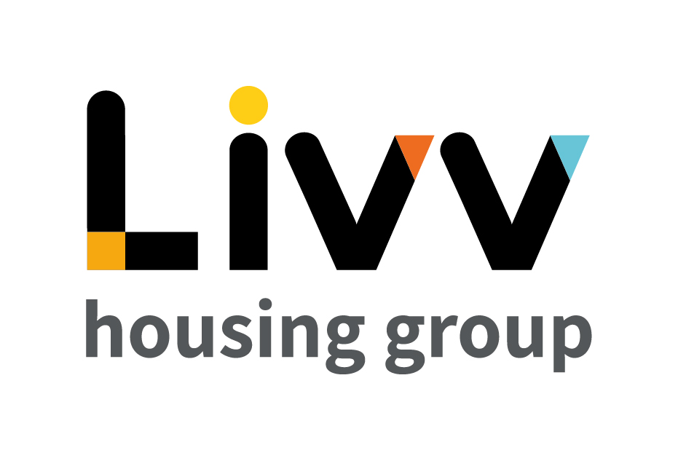

Job description

Job overview
Job title | Advisor - Housing
Department | Customer Relationship Management | Directorate | Customer Insight
Reports to | Manager - Housing | Date | January 2021
Responsible for | No Direct Reports | Job ref  Salary Range  (WEF April 2021) | CI018  £27100 - £32875
Overall team / department purpose
With the overall aim of building strong customer relationships, sustaining tenancies, maximising income and ensuring the creation and management of safe and sustainable neighbourhoods, the Customer Relationship Management Team is responsible for all customer contact and issue resolution that either cannot be resolved at first point of contact or that comes from our proactive tenancy management role. The team comprises of:
  - Customer Relationship Management (CRM), which is responsible for being the primary contact for the customer throughout their tenancy, identifying where customers need additional support to maintain their tenancies and the management of safe communities. Resolution of complex queries that cannot be resolved at first point of contact sit alongside income collection that requires additional professional support and the responsibility for the resolution of complex queries and all complaints.
  - Advisory Services teams provide specialist support and guidance to customers for a defined period based on presenting need to enable them to sustain their tenancy and remain safe in their home and their community. These teams work closely with the Housing Advisors on a case management basis with the Housing Advisors maintaining the customer relationship at all times. Advisory Services also develops and maintain a network of partners to ensure that we can advocate for customers and works with partners on Safeguarding and ensuring safe and secure communities

Key role priorities
This role is responsible for the delivery of an on-going customer facing ‘frontline worker’ service for the
Group’s customers, providing non-complex relationship management and support, acting as advocate for customers and referring to specialist services /other functions where required.

Key working relationships
The role holder is required to work in partnership with colleagues across all Customer Insight functions and the Group more generally (e.g. assets, property, development) to deliver the required levels of customer service. Externally the main focus for the role is to liaise with neighbourhoods, communities and customers directly, visiting customers homes and being generally visible in their designated geographical area.
The role is required to interact with resident groups and a range of 3rd parties to best understand needs and determine actions required.

Main duties & responsibilities
- Provide a relationship service to all customers within their designated geographical area across all tenures, working in partnership with complex queries and case workers to bring the best resolution for the customer.
- Determine where interventions are required to enable the customer to sustain their tenancy, referring the customer to the appropriate team or 3rd party and maintaining oversight to ensure the desired outcomes are achieved.
- Lead the tenancy sign up process, ensuring customers are on boarded in a way that enables them for success and able to sustain their tenancy. Ensure that the customer is aware of the requirements of their Tenancy (e.g. paying rent, keeping shared spaces safe), supporting them to maintain compliance and enforcing these requirements with the customer where necessary.
- Work across teams and with customers to ensure that empty homes are let seamlessly and in line with Group targets.
- Pro-actively manage the neighbourhoods that fall under their designated geographical area, ensuring that communities are safe and clean, and all shared spaces meet health & safety requirements. Lead their programme of customer visits, undertaking a number of proactive visits each year (driven by the needs of the customer).
- Pro-actively support the delivery of all compliance activity
- Input to the neighbourhood and community plans to improve the neighbourhoods.
- Ensure systems are updated with accurate and up to date information so that other teams are aware of the status of customer requests.
- Lead the delivery of support plans for customers across all tenures, in particular supported housing and Extra Care.
- Identify opportunities to improve the processes and feed these to the Manager, Housing.
- Complete any other tasks as commensurate with the level and nature of the post as delegated by the role’s line manager.

IREMENTS
Key measures of success
- Process compliance (time, cost, quality)
- Customer Satisfaction
- Tenancies Sustained
- Lettings
- Maximise Income
- KMBC Contract delivery (Independent Living)

General
All employees are expected to:
- Ensure that our Customers are at the heart of everything we do and act at all times in accordance with our Values and Behaviours.
- Carry out all duties in the context of, and in compliance with, the Group’s commitment to equality and diversity, leading by example and contributing to an inclusive culture.
- Read, understand and demonstrate a commitment to the Group’s Employee Charter.
- Take responsibility for your own health and safety and that of your colleagues in accordance with the Health & Safety at Work Act by following the Group’s Health and Safety policies and procedures at all times.
- Ensure compliance with all legal obligations concerning the protection of data concerning employees, customers and third parties.
- Be prepared to have some reasonable flexibility of working hours as necessary to meet the requirements of the job.
- Adopt a proactive approach to identify and mitigate risks to each business area by informing your line manager to enable the risk register to be updated, thus minimising the Group’s existing and future risks.
- Be prepared to work in a variety of locations as required, including premises not directly under the control of the Group.
- Demonstrate a willingness to undertake ongoing training as appropriate for ongoing personal and professional development

Values and Behaviours
Making a difference daily | We invest in our people, our customers and in the creation of a fairer society.
Positively open | We are open to feedback at all time, as we strive to deliver a first class customer experience.
Forging the right way | We’re creating an inspiring road which others will want to follow
Together as one | Our teams work on another level of cohesiveness to enable us to deliver better outcomes.

Person specification
 | Essential | Desirable
Education and Qualifications
3 GCSEs (Level 4 or above) or equivalent relevant customer service experience  Housing or other relevant qualification | X | X
Experience
Previous experience in a housing advisory role  Customer facing experience, ideally in a housing or other not for profit/service providing organisation | X | X
Involvement with community/tenants in a support capacity  Experience of working in the field of sheltered and supported housing/independent living  Experience of making referrals and working with external agencies to meet the needs of a customer |  | X  X  X
Experience of carrying out needs assessments and producing plans accordingly |  | X
Skills, knowledge and ability
Housing management legislation and policies |  | X
Strong communication, teamwork, interpersonal and organising skills | X
Ability to adapt to different situations | X
Able to initiate and maintain enabling relationships, including with vulnerable customers with a range of complex needs | X
Safeguarding knowledge / experience |  | X
IT skills, including use of Microsoft Office packages | X
Personal characteristics
Ability to work under pressure and meet deadlines | X
Confident and resilient | X
Other
Role involves ‘on call’ provision and frequent visibility within communities and neighbourhoods and to customers’ homes  Flexible approach to hours worked (including Saturday mornings)  Must be able to travel independently  Must have met requirements of DBS Check | X  X  X  X

