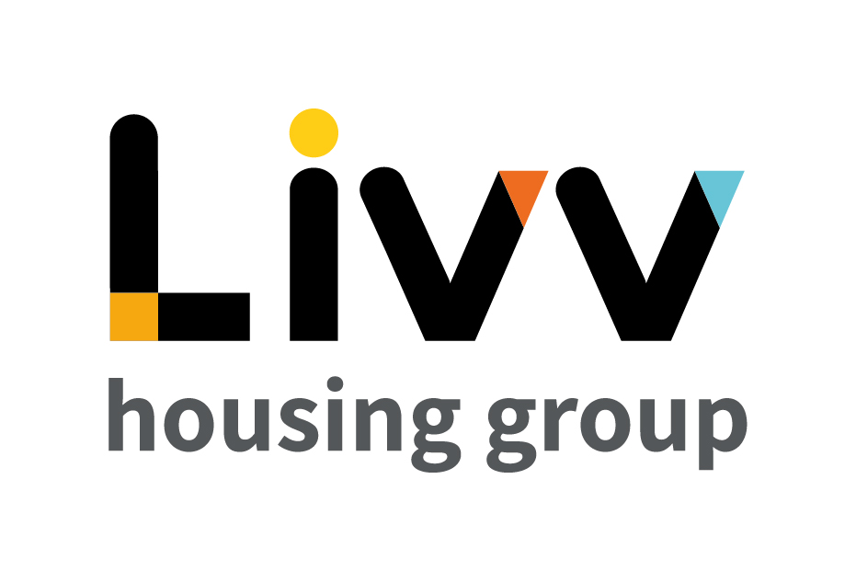

Job description

Job overview
Job title | Officer – Customer Liaison (Extra Care)
Department | Customer Relationship Management | Directorate | Customer Insight
Reports to | Manager - Housing | Date | January 2021
Responsible for | No Direct Reports | Job ref  Salary Range  (WEF April 2021) | CI019  £22578 - £27987
Overall team / department purpose
With the overall aim of building strong customer relationships, sustaining tenancies, maximising income and ensuring the creation and management of safe and sustainable neighbourhoods, the Customer Relationship Management Team is responsible for all customer contact and issue resolution that either cannot be resolved at first point of contact or that comes from our proactive tenancy management role.
The team comprises of:
  - Customer Relationship Management (CRM), which is responsible for being the primary contact for the customer throughout their tenancy, identifying where customers need additional support to maintain their tenancies and the management of safe communities. Resolution of complex queries that cannot be resolved at first point of contact sit alongside income collection that requires additional professional support and the responsibility for the resolution of complex queries and all complaints.
  - Advisory Services teams provide specialist support and guidance to customers for a defined period based on presenting need to enable them to sustain their tenancy and remain safe in their home and their community. These teams work closely with the Housing Advisors on a case management basis with the Housing Advisors maintaining the customer relationship at all times. Advisory Services also develops and maintain a network of partners to ensure that we can advocate for customers and works with partners on Safeguarding and ensuring safe and secure communities.

Key role priorities
This role is responsible for the delivery of an excellent customer experience to all tenants and visitors to the Extra Care Scheme building.

Key working relationships
The role holder is required to work in partnership with colleagues across Customer Insight and with other functions such as Facilities and Procurement across the Group as necessary. External to the Group, the holder is required to deal directly with customers and visitors and with 3rd party stakeholders to deliver the required levels of customer service to them.

Main duties & responsibilities
- Provide a support service for the Extra Care Scheme, responding to requests from customers and visitors and supporting channel shift to digital routes to service.
- Undertake basic customer servicing requests, e.g. take payments for rent where other digital means cannot be utilised, respond to low level ASB issues.
- Work in partnership with other teams to deliver the required level of customer service (e.g. liaise with the caretaker and other teams to resolve building issues).
- Perform day to day liaison with the 3rd parties who provide a service in the building (e.g. caterer, hairdresser), in support of Operational Planning & Service Improvement.
- Undertake risk assessments for the Extra Care building.
- Ensure systems are updated with accurate and up to date information so that other teams are aware of the status of customer requests.
- Identify opportunities to improve the processes and feed these to the Manager, Housing.
- Complete any other tasks as commensurate with the level and nature of the post as delegated by the role’s line manager.

IREMENTS
Key measures of success
- Process compliance (time, cost, quality)
- Customer Satisfaction

General
All employees are expected to:
- Ensure that our Customers are at the heart of everything we do and act at all times in accordance with our Values and Behaviours.
- Carry out all duties in the context of, and in compliance with, the Group’s commitment to equality and diversity, leading by example and contributing to an inclusive culture.
- Read, understand and demonstrate a commitment to the Group’s Employee Charter.
- Take responsibility for your own health and safety and that of your colleagues in accordance with the Health & Safety at Work Act by following the Group’s Health and Safety policies and procedures at all times.
- Ensure compliance with all legal obligations concerning the protection of data concerning employees, customers and third parties.
- Be prepared to have some reasonable flexibility of working hours as necessary to meet the requirements of the job.
- Adopt a proactive approach to identify and mitigate risks to each business area by informing your line manager to enable the risk register to be updated, thus minimising the Group’s existing and future risks.
- Be prepared to work in a variety of locations as required, including premises not directly under the control of the Group.
- Demonstrate a willingness to undertake ongoing training as appropriate for ongoing personal and professional development.

Values and Behaviours
Making a difference daily | We invest in our people, our customers and in the creation of a fairer society.
Positively open | We are open to feedback at all time, as we strive to deliver a first class customer experience.
Forging the right way | We’re creating an inspiring road which others will want to follow
Together as one | Our teams work on another level of cohesiveness to enable us to deliver better outcomes.

Person specification
 | Essential | Desirable | Method of Assessment (see list below)
Education and Qualifications
3 GCSEs (Level 4 or above) or equivalent relevant customer service experience | X |  | AF, Certificates
Experience
Experience of working in a professional reception environment and dealing politely and professionally with staff and customers and members of the public | X |  | AF, I
Experience of working in a similar field, e.g. Independent Living |  | X | AF, I
Experience of coordinating services by 3rd parties |  | X | AF, I
Experience in a facilities management / service provision role |  | X | AF, I
Experience of working in an administration environment, including data input and management of effective systems | X |  | AF, I
Undertaking risk assessments |  | X | AF, I
Skills, knowledge and ability
IT skills, including use of Microsoft Office applications | X |  | AF, I
Excellent communication (oral and written) and interpersonal skills | X |  | AF, I
Personal characteristics
Highly customer focused approach | X |  | AF, I
Ability to work well under pressure | X |  | AF, I
Confident, helpful and enthusiastic attitude | X |  | AF, I
Other
Flexibility in approach as may be required to work out of office hours | X |  | AF, I

AF = Application form I = Interview T = Testing

