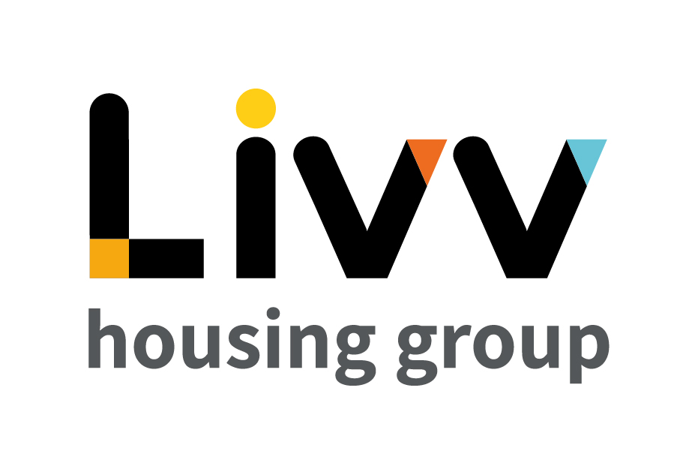

Job description

Job overview
Job title | Manager - Facilties
Department | Livv Maintenance | Directorate | Property
Reports to | Business Manager Repairs & Compliance | Date | September 2021
Directly responsible for | Team Leader - Facilities  Coordinator Compliance | Job ref | LM1
Salary Range WEF April 2021 | £36,419 - £45,992
Overall team / department purpose
- The delivery of a flexible and accountable customer facing facilities management (FM) service that ensures our neighbourhoods and communal properties are safe, kept to a high standard and are compliant.
- The team is responsible for the delivery of the Group’s FM and estates activity, its continuous improvement and the maximisation of value for money in its delivery. This includes the delivery of all applicable statutory and non-statutory compliance tasks either directly or indirectly through an appropriately appointed supply chain. The team are to act as a focal point for customer engagement at our communal properties, and to proactively report on their condition and take ownership of any remedial actions.
- The team will lead on controlling the access of third parties to our communal properties through a permit to work arrangement and will work in conjunction with other Group teams to ensure the safe delivery of planned or remedial services.

Key role priorities
- Accountable for ensuring the most effective delivery of FM and estates services, enabling the Group to deliver high standards and services that meet the expectations of customers.
- This includes the coordination of teams to meet all agreed targets, statutory obligations and mandatory health & safety, regulatory and security standards, escelating the risk of non-compliance in a timely manner to ensure mitigating actions can be implemented.
- The role requires the dynamic leadership of the team to deliver its ongoing programme of services and the provision of a reactive service for risk remediation. The leader will maintain a flexible approach to resolving emerging challenges as they arise, through the close liaison with the Assets & Compliance team for the prioritisation of expenditure.
- Working in partnership with all key stakeholders (internal and external) to ensure that all services are delivered safely, in line with Group requirements, efficiently within budget and to the required standard of quality, adding value at every opportunity.

Key working relationships
- Overall responsibility for the Facilities management Team and direct line management of the Team Leader Facilities and Coordinator Compliance.
- Required to work with internal and external stakeholders and partners including external experts, sub-contractors and suppliers.

Main duties & responsibilities
- To lead the facilities management team to meet all agreed targets for FM services across all Communal properties and Group offices delivering an evidence led approach to compliance and the effective delivery of repairs and risk remediation.
- Ensure the delivery of clearly demonstrable value for money services that are maintained within agreed budgetary parameters.
- Regularly review operational productivity and structure the team to maximise performance and efficiency in delivery of the services
- Ensure the effective management of all supply chain and subcontractor partners to ensure compliance with contractual requirements are met, in line with the management of Contractors framework.
- Provide financial performance updates and financial forecasts on a monthly basis to ensure clarity of expenditure and budgetary risks.
- Contribute to the preparation of annual budgets and the investment plan requirements for Communal properties and Group offices providing evidence led recommendations that maximise asset values.
- Contribute to the build and development of a successful and experienced FM team through the coaching and development of all team members.
- Ensure compliance with all aspects of Health & Safety legislation and internal H&S Management Systems across the team, including in training development and continuous improvement, focusing on the eradication of injuries at work.
- Ensure compliance with all aspects of the Group’s Quality Management Systems and business processes across the function.
- Complete any other tasks as commensurate with the level and nature of the post as delegated by the role’s line manager.

Key measures of success
- The delivery of all agreed targets for FM services across all Communal properties and Group offices including the continous compliance of statutory property obligations
- The delivery of targeted levels of customer satisfaction through the effective cleanliness and maintenance of communal properties
- Evidenced continual improvement across the delivery of all services and managed contracts
- Adherence to all Group policies and regulations.

General
All employees are expected to:
- Ensure that our Customers are at the heart of everything we do and act at all times in accordance with our Values and Behaviours.
- Carry out all duties in the context of, and in compliance with, the Group’s commitment to equality and diversity, leading by example and contributing to an inclusive culture.
- Read, understand and demonstrate a commitment to the Group’s Employee Charter.
- Take responsibility for your own health and safety and that of your colleagues in accordance with the Health & Safety at Work Act by following the Group’s Health and Safety policies and procedures at all times.
- Adhere to all Group policies at all times.
- Understand and demonstrate empathy with the social aims of the Group.
- Ensure compliance with all legal obligations concerning the protection of data concerning employees, customers and third parties.
- Be prepared to have some reasonable flexibility of working hours as necessary to meet the requirements of the job.
- Adopt a proactive approach to identify and mitigate risks to each business area by informing your line manager to enable the risk register to be updated, thus minimising the Group’s existing and future risks.
- Be prepared to work in a variety of locations as required, including premises not directly under the control of the Group.
- Demonstrate a willingness to undertake ongoing training as appropriate for ongoing personal and professional development and in line with the Group’s commitment to continuous improvement; demonstrate ongoing continuing professional development and take responsibility for identifying own development needs and actions to address these where appropriate.

Values and Behaviours
Making a difference daily | We invest in our people, our customers and in the creation of a fairer society.
Positively open | We are open to feedback at all time, as we strive to deliver a first-class customer experience.
Forging the right way | We’re creating an inspiring road which others will want to follow
Together as one | Our teams work on another level of cohesiveness to enable us to deliver better outcomes.

Person specification
 | Essential | Desirable | Method of Assessment (see list below)
Education and Qualifications
Evidence of managing facilities management contracts | X |  | AF/I
Membership of Relevant Professional Body (e.g. IWFM, CIH, CIOB) |  | X | AF
Evidence of continuous professional development | X |  | AF/I
Experience
Managing contract budgets and cash flows | X |  | AF/I
Managing operational teams to deliver high performance | X |  | AF/I
Negotiating subcontractor / supplier contracts | X |  | AF/I
Mobilisation of operational contracts | X |  | AF/I
Liaison with internal and external stakeholders to manage neighbourhoods | X |  | AF/I
Working with contractors, monitoring and attaining high performance | X |  | AF/I
Skills, knowledge and ability
Understanding of cash forecasting and budgetary control | X |  | AF/I
Ability to review operational productivity and implement corrective methods to increase performance | X |  | AF/I
Excellent communication skills, both written and verbal, to internal and external stakeholders | X |  | AF/I
Ability to analyse business critical data to identify issues, successes and trends. | X |  | AF/I
Personal characteristics
A strong leader who communicates with clear direction and focus | X |  | I
Ability to organise and prioritise work, ability to delegate effectively and build a cross functional resilient team | X |  | I
Embraces collaboration with other business sections, partners and stakeholders | X |  | I
Other
Must have own transport | X |  | AF/I
Flexible approach to hours worked | X |  | AF/I

AF = Application form I = Interview T = Testing

