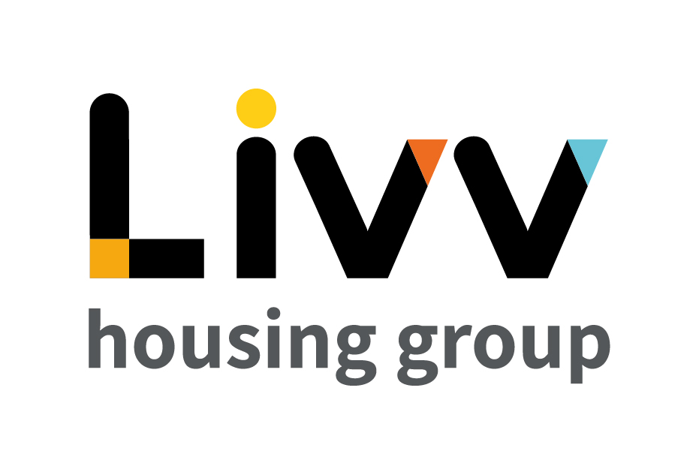

Job description

Job overview
Job title | Advisor - Customer Service
Department | Contact Centre, Customer Services | Directorate | Customer Insight
Reports to | Team Coach – Contact Centre | Date | January 2021
Responsible for | No Reports | Job ref  Salary Range  (WEF April 2021) | CI032  £21015 - £24623
Overall team / department purpose
The Customer Services Team is the enabling and supporting team within Customer Insight. It is both the front door to the organisation for customers and the enabling function for the wider Customer Insight Directorate via its processing capability.
Customer Services comprises the Contact and Processing Centres:
- The Contact Centre is responsible for receiving all inbound customer and other stakeholder enquiries and resolving the majority at first contact as well as providing some outbound support services to the broader Directorate functions.
- The Processing Centre is responsible for both internal and external Contract Service Delivery and back office processing to support the customer facing teams in the execution of end to end processes including allocations and lettings, tenancy management and income collection.

Key role priorities
This role is responsible for delivering an excellent customer service in accordance with agreed policies and procedures, providing resolution at first point of contact for all incoming telephone calls, emails and webchat requests from existing customers and other external stakeholders and providing support to the broader Customer Insight function as required through making outbound calls and data recording and collection.

Key working relationships
Beyond interaction with Contact Centre colleagues, these role holders are predominantly required to interact with customers and other external stakeholders who contact the Contact Centre by telephone, email or webchat. This includes existing, previous and potential customers, Choice Based Lettings Applicants and other stakeholders e.g. Managed Agents. Whilst required to deal with the majority of incoming enquiries at first point of contact, the role is also required to interact with other teams across the Directorate and Group, e.g. Advisory Services, Income Collection, Maintenance where necessary to resolve enquiries, passing ownership to the 2nd line support in each case.

Main duties & responsibilities
- Respond to all incoming customer enquiries ensuring customer ease and customer satisfaction are maximised.
- Provide detailed and accurate information on the Group’s product and, services and resolve queries at the first point of contact.
- Ensure up to date product and service knowledge is maintained at all times; take responsibility for identifying personal development needs and agree actions to progress these with the Team Coach.
- Maintain accurate customer records, retrieving and inputting information following each interaction, in particular updating and maintaining the Customer Relationship Management.
- Support the wider business with customer interactions through the making and recording of outbound calls.
- Ensure customers acre accessing services through the appropriate channels, supporting channel shift and delivering value for money.
- Work in partnership with other teams to deliver market leading customer service.

IREMENTS
Key measures of success
- All incoming enquiries are resolved at first point of contact wherever within the ability of CSA to do so given policies and procedures.
- Contacts are answered within agreed service standards (time, cost and quality)
- Individual customer satisfaction scores meet the agreed standard.
- Contact quality standards are achieved.
- Maximise Income
- All assessments for knowledge, process and compliance achieve agreed standard.

General
All employees are expected to:
- Ensure that our Customers are at the heart of everything we do and act at all times in accordance with our Values and Behaviours.
- Carry out all duties in the context of, and in compliance with, the Group’s commitment to equality and diversity, leading by example and contributing to an inclusive culture.
- Read, understand and demonstrate a commitment to the Group’s Employee Charter.
- Take responsibility for your own health and safety and that of your colleagues in accordance with the Health & Safety at Work Act by following the Group’s Health and Safety policies and procedures at all times.
- Ensure compliance with all legal obligations concerning the protection of data concerning employees, customers and third parties.
- Be prepared to have some reasonable flexibility of working hours as necessary to meet the requirements of the job.
- Adopt a proactive approach to identify and mitigate risks to each business area by informing your line manager to enable the risk register to be updated, thus minimising the Group’s existing and future risks.
- Be prepared to work in a variety of locations as required, including premises not directly under the control of the Group.
- Demonstrate a willingness to undertake ongoing training as appropriate for ongoing personal and professional development

Values and Behaviours
Making a difference daily | We invest in our people, our customers and in the creation of a fairer society.
Positively open | We are open to feedback at all time, as we strive to deliver a first class customer experience.
Forging the right way | We’re creating an inspiring road which others will want to follow
Together as one | Our teams work on another level of cohesiveness to enable us to deliver better outcomes.

Person specification
 | Essential | Desirable | Method of Assessment (see list below)
Education and Qualifications
3 GCSEs (Level 4 or above) or equivalent relevant customer service experience | X |  | AF / certificates
Experience
Experience of operating effectively in a customer facing/service environment | X |  | AF,I
Experience of working in a team environment |  | X | AF,I
Skills, knowledge and ability
Excellent communications skills | X |  | I
Good problem solver | X |  | I
Personal characteristics
Customer Focused | X |  | I
Confident and Resilient | X |  | I
Other
Flexible approach to hours worked (including evenings and Saturday mornings) | X |  | I

AF = Application form I = Interview T = Testing

