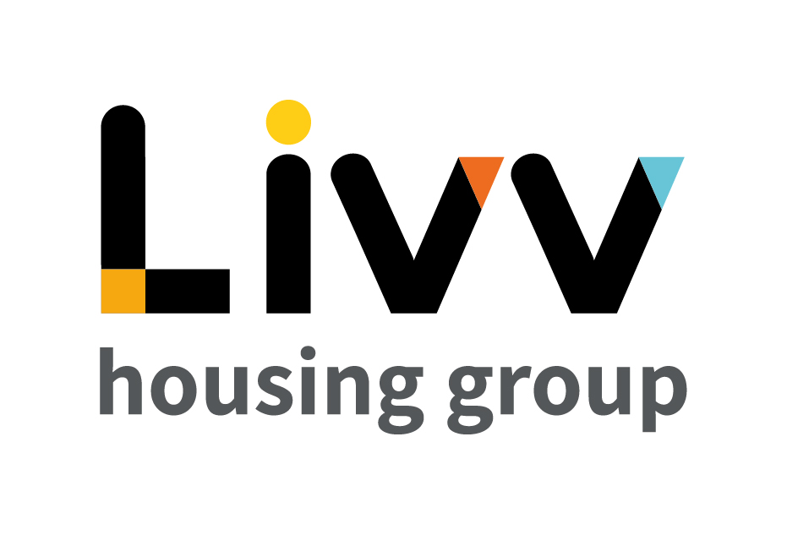

Job description

Job overview
Job title | Officer – Complex Queries & Complaints
Department | Customer Relationship Management | Directorate | Customer Insight
Reports to | Manager – Complex Queries & Complaints | Date | January 2021
Responsible for | No Direct Reports | Job ref  Salary Range  (WEF April 2021) | CI020  £25402 - £30069
Overall team / department purpose
With the overall aim of building strong customer relationships, sustaining tenancies, maximising income and ensuring the creation and management of safe and sustainable neighbourhoods, the Customer Relationship Management Team is responsible for all customer contact and issue resolution that either cannot be resolved at first point of contact or that comes from our proactive tenancy management role. The team comprises of:
  - Customer Relationship Management (CRM), which is responsible for being the primary contact for the customer throughout their tenancy, identifying where customers need additional support to maintain their tenancies and the management of safe communities. Resolution of complex queries that cannot be resolved at first point of contact sit alongside income collection that requires additional professional support and the responsibility for the resolution of complex queries and all complaints.
  - Advisory Services teams provide specialist support and guidance to customers for a defined period based on presenting need to enable them to sustain their tenancy and remain safe in their home and their community. These teams work closely with the Housing Advisors on a case management basis with the Housing Advisors maintaining the customer relationship at all times. Advisory Services also develops and maintain a network of partners to ensure that we can advocate for customers and works with partners on Safeguarding and ensuring safe and secure communities.

Key role priorities
This role is responsible for ensuring the effective resolution of complex requests and complaints, delivering appropriate customer outcomes in line with Group policies and objectives in response to complaints and enquiries raised by other parts of the Group and/or that cannot be handled by Housing Advisors given the need for specialist knowledge or multiple steps being involved which require the application of judgement.

Key working relationships
The role holder is required to work in partnership with colleagues across Customer Insight and more generally across the Group as required to deliver the required levels of customer service. Externally the role holder is required to deal with customers directly by telephone, email and pre-arranged face to face meetings and with 3rd parties in responding to complex queries, e.g. MPs and Councillors.

Main duties & responsibilities
- Lead the resolution of complaints and of complex queries in a proactive manner, managing the relationship with the customer and providing all content to bring about resolution. This in accordance with the Complaints Policy (complaints) and agreed procedures and tenancy agreements (complex queries), in both cases placing the customer at the heart of the service.
- Proactively manage feedback received through Customer feedback software and address customer concerns to reduce the number of formal complaints received.
- Proactively manage the relationship with Councillors and MPs to manage enquiries and reduce the number of formal complaints received.
- Analyse trends for complaints and queries and identify areas to improve the service and feed these to the Manager, Complex Queries & Complaints.
- Work in partnership with other teams to deliver the required level of customer service.
- Ensure systems are updated with accurate and up to date information so that other teams are aware of the status of customer requests.
- Undertake the resolution of complaints and of complex queries in a proactive manner, in accordance with Complete any other tasks as commensurate with the level and nature of the post as delegated by the role’s line manager.

IREMENTS
Key measures of success
- Process compliance (time, cost, quality)
- Customer Satisfaction
- Tenancies Sustained
- Complaints KPIs - dealing with complaints within agreed response times and with relevant escalations

General
All employees are expected to:
- Ensure that our Customers are at the heart of everything we do and act at all times in accordance with our Values and Behaviours.
- Carry out all duties in the context of, and in compliance with, the Group’s commitment to equality and diversity, leading by example and contributing to an inclusive culture.
- Read, understand and demonstrate a commitment to the Group’s Employee Charter.
- Take responsibility for your own health and safety and that of your colleagues in accordance with the Health & Safety at Work Act by following the Group’s Health and Safety policies and procedures at all times.
- Ensure compliance with all legal obligations concerning the protection of data concerning employees, customers and third parties.
- Be prepared to have some reasonable flexibility of working hours as necessary to meet the requirements of the job.
- Adopt a proactive approach to identify and mitigate risks to each business area by informing your line manager to enable the risk register to be updated, thus minimising the Group’s existing and future risks.
- Be prepared to work in a variety of locations as required, including premises not directly under the control of the Group.
- Demonstrate a willingness to undertake ongoing training as appropriate for ongoing personal and professional development

Values and Behaviours
Making a difference daily | We invest in our people, our customers and in the creation of a fairer society.
Positively open | We are open to feedback at all time, as we strive to deliver a first class customer experience.
Forging the right way | We’re creating an inspiring road which others will want to follow
Together as one | Our teams work on another level of cohesiveness to enable us to deliver better outcomes.

Person specification
 | Essential | Desirable | Method of Assessment (see list below)
Education and Qualifications
3 GCSEs (Level 4 or above) or equivalent relevant customer service experience  Housing Relevant qualification | X | X | AF, Certificates  AF, Certificates
Experience
Previous experience in complaint handling and / or resolution techniques for managing complex (multiple step / cross – functional) enquiries. | X |  | AF, I
Previous experience in a housing / service sector organisation in a customer facing role | X |  | AF, I
Skills, knowledge and ability
IT skills, including Microsoft Office applications | X |  | AF, I
Excellent communication (oral and written), teamwork and interpersonal skills | X |  | AF, I
Knowledge of the legal requirements of tenancy agreements and actions for breaches |  | X | AF, I
Ability to explain complex information in simple terms and to provide guidance to a diverse range of people | X |  | AF, I
Personal characteristics
Methodical and keen attention to detail | X |  | AF, I
Confident, resilient and empathetic attitude – able to deal with conflict / difficult situations in a professional manner | X |  | AF, I
Ability to work under pressure and to meet deadlines | X |  | AF, I
Other
Flexibility in approach to working hours and location – role includes travel to customers’ homes | X |  | AF, I
Must be able to travel independently | X |  | AF, I

AF = Application form I = Interview T = Testing

